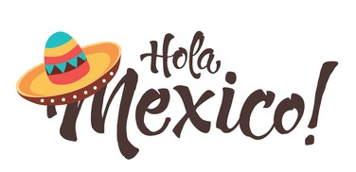
Year 6 Summer 2 Project homework
Hola Mexico!

Find out more about Maya hieroglyphs and symbols. Can you write your name or a short message to a friend? | Design and build a Maya temple using junk materials, such as cardboard boxes, newspaper and card. | Try making musical instruments – simple drums, guitars, shakers – from everyday household objects, like plastic bottles, elastic bands, and rice. | Find out more about what the Maya believed in and present the information any way you like.
Your own idea!  Be as creative as you want. | Make a typical Mexican dish, such as guacamole or tacos! | Uncover some of the myths about the Maya and the reasons they are fake.  Ensure you have adult permission/supervision to use the internet for research. | In Mexico, the most common spoken language is Spanish. Can you find out how to say some phrases in Spanish? Do you know anyone who speaks Spanish? Impress them with a Spanish conversation!
Research the ancient Maya legend of the Dwarf of Uxmal. Produce a comic strip, picture board or short children’s book to tell the story. | Find out about Mexican flowers, trees and animals. Some are very different to those found in the UK! Record what you learn. | Help a sibling with their homework and provide evidence. | Find a powerful image of a Maya God or Goddess and bring it to life using drama – think about the way they would have looked, stood and walked and take photographs of yourself in that role. Annotate the photos to explain your thoughts.

Please complete at least one task over the half-term and send them in as soon as they are complete. While restrictions are in place, the best way to submit your child’s homework is to send a photo on Class Dojo. You could also attach a photograph of a model, PowerPoint, Word document etc. Tasks can be completed in a variety of ways – be as creative as you want!

