Year 5 Summer 2 Project homework – Alchemy Island
Read The Lion, the Witch and the Wardrobe or Harry Potter and the Philosopher’s Stone. Write a review for your friends; be sure to describe the main characters.  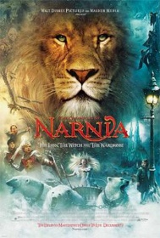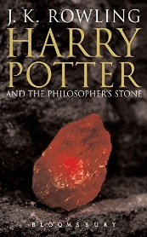 | Use a magnet to test the magnetic properties of metals around your home and record your discoveries in a data table.  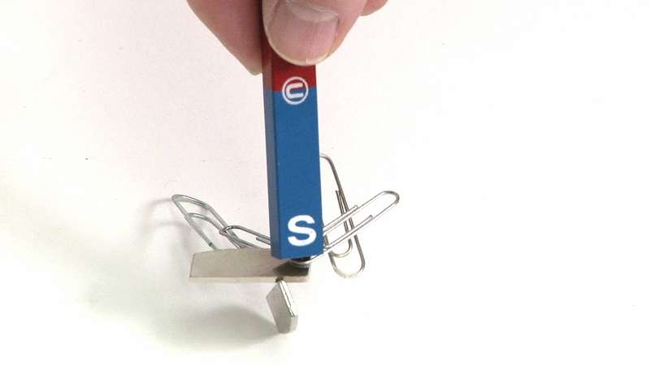 | Research how chemists create new materials, for example, Spencer Silver, who invented the glue for sticky notes or Ruth Benerito, who invented wrinkle-free cotton.  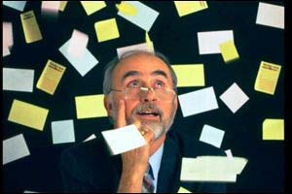 | Find (and play if you can) a piece of music that exemplifies the discovery of hidden gold. Turn off the lights, lay still in a quiet space and close your eyes. Listen intently to a range of classical or fantasy music from films or computer games, letting your imagination explore images that the music creates. Use a notebook to describe how the music makes you feel and think. Discuss your views with your family and vote for your favourite piece of music.
Find out if your family owns anything containing gold or another precious metal or gemstone. What can you find out about where it came from? Create a fact sheet with key information and photographs/ drawings. | Combine art and science to make an astonishing and unique gemstone! Experiment with materials such as wax, resin, plaster and jelly! | Find out the atomic numbers and symbols for metals, such as lead, copper, silver, zinc, iron and platinum. | Design a costume and travel kit for an alchemist. What useful things might an alchemist pack in a suitcase?
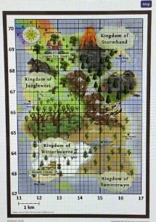  Design a new board game called  Alchemy Island. Think back to  the original Island map to make  sure geographical features  and places are represented.  Devise a set of rules for how  to play the game. Design any  game pieces you will need,  possibly using printed cut-outs of your game characters, 3-D models or any other materials created as part of your Island adventure. |  | Read a range of settings described in children’s fantasy books, such as The Shadow Forest by Matt Haig, Ignis by Gina Wilson or The Wizard of Earthsea by Ursula Le Guin. Highlight examples of figurative language – words, phrases and sentences that appeal to the senses and help to create a picture of the setting. Cut out examples of words, phrases and sentences and explore ways of reordering, editing and listing them. Add extra words and phrases to create a new narrative or word collage.  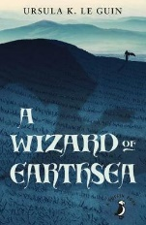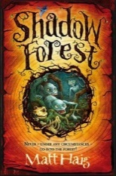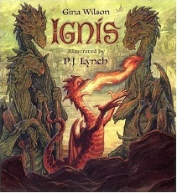
Please complete THREE tasks over the half-term and send them in as soon as they are complete. While restrictions are in place, the best way to submit your child’s homework is to send a photo on Class Dojo. You could also attach a photograph of a model, PowerPoint, Word document etc. Tasks can be completed in a variety of ways – be as creative as you want! You can also think of your own project homework idea or help a sibling with their project homework.
Be as creative as you want - you might have your own idea!

