Project homework – Off with Her Head!

Make a Tudor brooch, ring or headdress. Take a photograph of yourself wearing your item in your most ‘stately’ pose. | Design a Tudor snakes and ladders-style board game, with pitfalls and lucky breaks on the way to freedom from the Tower. | 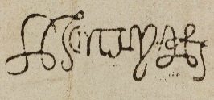  Find and copy examples of monarch’s signatures. Can you create a magnificent, Tudor-style moniker (signature) of your own? | Make a model of the Tower of London.
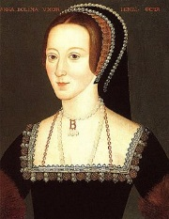  What can you find out about Anne Boleyn’s family and her childhood? Put your findings in a presentation to show the class. | Visit your local library or museum (or both) and find out about your area in Tudor times. Are there any maps, buildings or artefacts from that era? Create a scrapbook or poster of photos, leaflets and any other information you discover. | Do you have horrible humour? Write some ‘knock-knock’ or ‘What do you call a…?’ jokes for your class. Present a jester-style, stand up performance for your class. | Decorate an egg in the theme of  ‘Off with Her Head!’
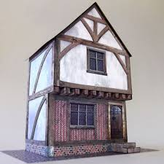  Discover all about Tudor buildings. Find out about the jetty, styles of chimney, wattle and daub and any other features you can. Create a model of a building in the Tudor style. Be creative with your materials. | Tudor times were a great period of sea voyages and global exploration. Find out the names of some Tudor explorers and the new products they brought home. Be creative in how you record your results! You could plot their journeys on a world map. | Make sketches of Tudor costumes  Watch this video of Tudor dancing https://www.bbc.co.uk/bitesize/clips/zt4kjxs  You could research Tudor dances and compose your own dance, using knowledge of the customs and lifestyle of Tudor people to inform your composition.  for children and adults, rich and  poor. Use websites and books  from your local library to find out  about garments, styles and  decorative details.
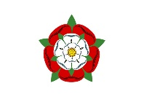
Please complete THREE over the half-term and send them in as soon as they are complete.
While restrictions are in place, the best way to submit your child’s homework is to send a photo on Class Dojo.
You could also attach a photograph of a model, PowerPoint, Word document etc.
Tasks can be completed in a variety of ways – be as creative as you want!

