Year 3 Summer 2 Project Homework – Urban Pioneers
Imagine you have been asked to design a new building to inspire the residents of your town or city. Design your architectural masterpiece and perhaps make a model of it! | Write your own name in ‘graffiti-style’ art work. You could use a range of materials. |  | Go gargoyle spotting! Look up in church yards and see if you are being watched by a stone gargoyle. Take photographs and then try to recreate a 3-D replica of the strange creatures at home, using modelling materials | Look at a striking urban landmark buildings such as the Gherkin or the Shard in London, or the Flat Iron building in New York. Make a collection of images you like in a scrapbook.
With an adult, go on a walking tour of a city, taking photographs of favourite buildings and places. Describe your route, using a map, to another person so they could make the same journey. You could make a map of your journey. | THIS BOX IS BLANK IN CASE YOU HAVE YOUR OWN IDEA | 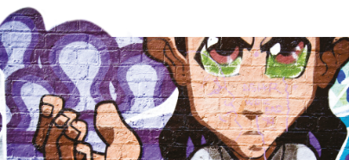 |  | What makes a great city? Is it the parks and water features, the friendly people or the clean, litter-free streets? Write a report including pictures about each feature you think makes a great city.
 | Imagine you have to entertain a visitor from another country. You want to impress them with your home town. Where would you take them for a day trip? Plan an itinerary showing them the best of your local area. |  | Find out about animals that live in the city, such as foxes, peregrine falcons and pigeons. Make a poster of the animals you have researched including their habitat and how they survive in an urban environment. | HELP A SIBLING WITH THEIR HOMEWORK & PROVIDE EVIDENCE
Please complete at least THREE tasks over the half-term and send them in as soon as they are complete. While restrictions are in place, the best way to submit your child’s homework is to send a photo on Class Dojo. You could also attach a photograph of a model, PowerPoint, Word document etc. Tasks can be completed in a variety of ways – be as creative as you want!

