Y3 Project homework - Predator (Autumn 2)
Come up with a food chain and make a hanging mobile out of it. | Investigate where in the world different predators can be found. Create a map or presentation to show what lives where! |  | Write a short poem from the perspective of a predator, e.g. an eagle looking down for prey, a lion stalking prey through the grasslands. (You could keep it simple with an acrostic poem or try a Haiku poem). | Make a fossil using a mouldable material such as clay or salt dough. Ensure that it is detailed and shows the skeleton of your chosen animal.
Create a fact file about a predator of your choice. | Make a collage of a predator of your choice. You could use different materials, pictures printed from the internet or cut out from magazines. | 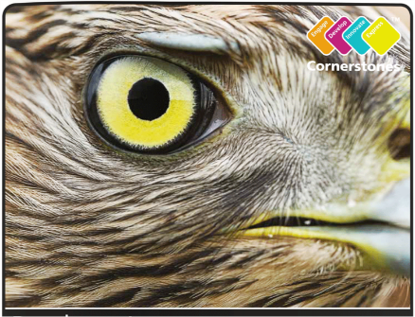 |  | Design your own predator. Does your predator have teeth like a lion? Is it fast like a cheetah? Does it have patterns like a leopard? What are you going to call it?  Draw or make a model of it!
 | Make a 3D model of a habitat for a predator of your choice e.g. jungle, aquatic.  (You could use a shoebox as the base/frame of your habitat). | Write a short story from the perspective of a predator or prey during an attack. |  | HELP A SIBLING WITH THEIR HOMEWORK & PROVIDE EVIDENCE
Please complete THREE over the half-term. While restrictions are in place, the best way to submit your child’s homework is to send a photo through ClassDojo. We will show them in class by the end of that week. You could attach a photograph, a PowerPoint, a Word document etc.
Tasks can be completed in a variety of ways - be as creative as you want!

