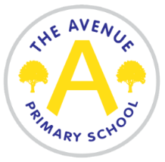
The Avenue Primary School
The Avenue
Nunthorpe
Middlesbrough
TS7 0AG
Tel: (01642) 318510
Head Teacher: Mrs Emma Watson
Head of School: Mrs Jayne Gibson

Lunchtime supervisor
Temporary in the first instance – fixed term until 19th July 2023
12-1pm Monday to Friday (term time only)
Required from 2nd September 2022
Annual salary £2181

We are seeking to employ a lunchtime supervisor.

The duties will include:

- Supervising children on the playground
- Reporting incidents and accidents to the appropriate members of staff
- Encouraging good behaviour on the playground and following the school’s behaviour policy
- Supporting children with games and outdoor play

The James Cook Learning Trust is committed to safeguarding and promoting the welfare of children and requires all staff and volunteers to share this commitment. Any offer of employment will be subject to evidence of eligibility to work in the UK, satisfactory DBS (previously CRB), medical clearance and references that recommend the candidate without reservation.
An application form can be found on the school website under the ‘vacancies’ section (www.theavenueprimaryschool.co.uk)

Applications should be returned by email to Jayne Gibson, avjayne.gibson@theavenueprimaryschool.co.uk

Closing date –14th July
Interviews – 15th July

