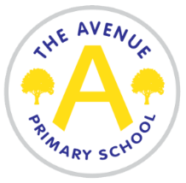
The Avenue Primary School
The Avenue
Nunthorpe
Middlesbrough
TS7 0AG
Tel: (01642) 318510
Head Teacher: Mrs Emma Watson

Lunchtime supervisor
Temporary in the first instance – fixed term until Friday 22nd July 2022
12-1.15pm Monday to Friday (term time only)
Required as soon as possible
Annual salary £2680

We are seeking to employ a lunchtime supervisor.

The duties will include:

- Supervising children on the playground
- Reporting incidents and accidents to the appropriate members of staff
- Encouraging good behaviour on the playground and following the school’s behaviour policy
- Supporting children with games and play
- Supporting all policies and procedures related to the management of Covid 19

The James Cook Learning Trust is committed to safeguarding and promoting the welfare of children and requires all staff and volunteers to share this commitment. Any offer of employment will be subject to evidence of eligibility to work in the UK, satisfactory DBS (previously CRB), medical clearance and references that recommend the candidate without reservation.
An application form can be found on the school website under the ‘vacancies’ section (www.theavenueprimaryschool.co.uk)

Applications should be returned by email to Lyndsey McLaren, lmclaren@theavenueprimaryschool.co.uk

Closing date – 27th January at 12 noon
Interviews - TBC

