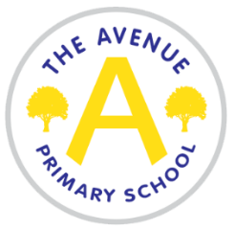
The Avenue Primary School
Background information

The Avenue Primary School became part of the James Cook Learning Trust in September 2018. The other schools that make up the trust are Marton Manor Primary, Lingfield Primary and Captain Cook Primary.

The Avenue is situated in Nunthorpe, Middlesbrough. The school has been serving the local community since the 1970s and continues to be an important part of the local community.

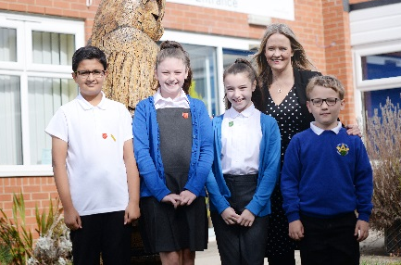
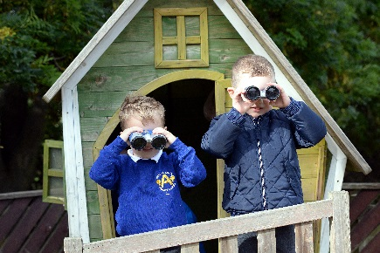
The Avenue Primary School currently has 414 pupils from Reception to Year 6 and a 30 place Nursery on a morning and afternoon. The School is made up of; Early Years Foundation Stage, Key Stage 1 and Key Stage 2.
At The Avenue Primary School we pride ourselves on providing a caring and friendly environment. Every child is encouraged to achieve their very best, having high expectations of themselves academically and socially, whilst understanding the contribution they can make to their school and the wider community.
Our School Motto, as created by the pupils and staff is:

We Learn We Grow We Shine

Mrs E Watson Mrs J Gibson
CEO /Executive Head Teacher Head of School

