Investigate the connection between the Vikings and York. Use this link to virtually explore Jorvik Viking Centre  https://www.jorvikvikingcentre.co.uk/discover-from-home/  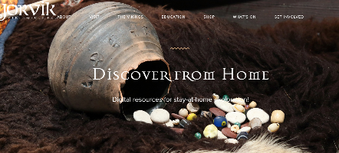  Write a summary of your findings. | Try baking Anglo Saxon or Viking flatbread (search online for recipes). | Watch the video clip below paying particular attention to the story of Beowulf.  https://www.bbc.co.uk/teach/class-clips-video/story-of-britain-anglo-saxon-britain/zdh2t39  Produce a piece of writing based on the tale. E.g.  A description of the fight  A diary entry from Beowulf’s perspective  A recount of the story  A character description of Grendel | Write a short message using the Futhark alphabet, using letters or ‘runes’ as they were known. Vikings wrote on wood, bone and stone. What will you choose?  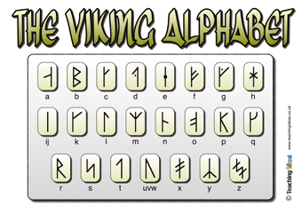
Look at images of Anglo-Saxon coins and design or make your own. http://www.bbc.co.uk/history/trail/conquest/wessex_kings/coins_cnut_york.shtml | Anglo Saxons and Vikings were fierce warriors. Research and make a weapon that they typically used in battle. | 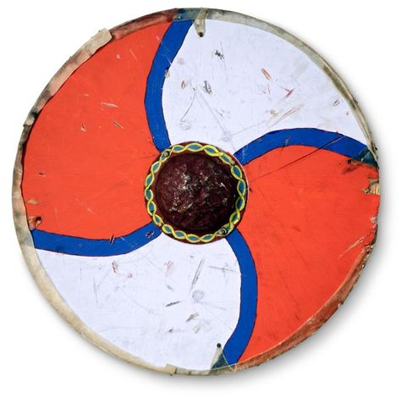  The shield was considered the most important piece of military equipment by Anglo Saxons. Design or make your own. | Draw, paint or create a poster or fact-file about a Viking God or Goddess.
Write a review of a book you have read.  Use the ‘Book Review Template’ from the Homework section on the school website to share your views with us and others in your family. | Your own idea.  Help a sibling. | Draw or make a map of Britain or Europe. Show where the Saxons and Vikings came from and/or how the country was divided between them. | Build an Anglo-Saxon or Viking home.  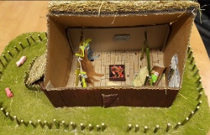  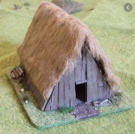  Think about the features of the home and write how it is different to our homes now.

Please complete THREE over the half-term and send them in as soon as they are complete. While restrictions are in place, the best way to submit your child’s homework is to send a photo on Class Dojo. You could also attach a photograph of a model, PowerPoint, Word document etc. Tasks can be completed in a variety of ways – be as creative as you want!

