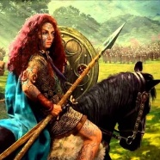
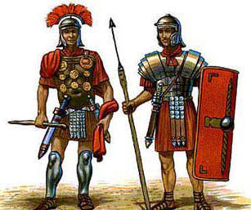
Y3 Spring 2 Project homework – I am Warrior! (Romans).
Make a Roman weapon, for example a soldier’s gladius (sword).  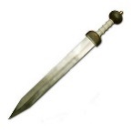 | Write some number calculations using Roman Numerals for a family member to solve. |  | Make a model of the Colosseum in Rome. You could use different materials such as cardboard tubes, cereal boxes, coloured paper and tinfoil. | Find out who were the different emperors of Rome. You could draw a picture of them/create a timeline showing when they ruled or even write about your favourite emperor.
Research Roman life (e.g. leisure, rich vs poor, housing) using books or the Internet and present your findings any way you like | Research famous Roman Gods. Create a fact file on one or even Top Trumps on several Gods. | 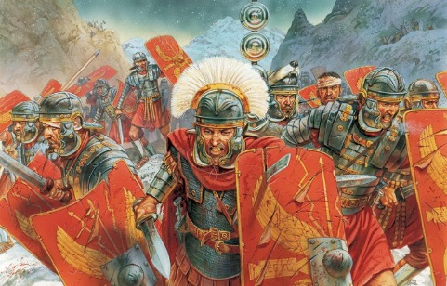  I am Warrior! | The Roman’s made mosaics that told a story. Create your own collage mosaic with its own story or recreate a famous Roman mosaic. You could use magazine as your material. An example is provided in the box below. | Find out about modern-day Rome. Find pictures and information about famous landmarks. You could even design a page advertising Rome for a holiday brochure.
 | 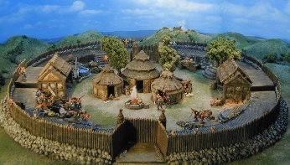  Design/make a Celtic village. | Find out about gladiators. Describe a battle between two gladiators, watched by thousands in the Colosseum. | 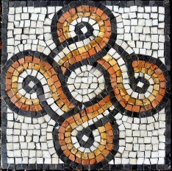 | HELP A SIBLING WITH THEIR HOMEWORK & PROVIDE EVIDENCE
Please complete THREE over the half-term and send them in as soon as they are complete. A box has been left empty in case you think of your own idea.
While restrictions are in place, the best way to submit your child’s homework is to send a photo on Class Dojo. You could also attach a photograph of a model, PowerPoint, Word document etc.
Tasks can be completed in a variety of ways – be as creative as you want!

