Project homework – Street Detectives - Spring Term 2
Our topic this term is called ‘Street Detectives’ which means we will be learning about our local area.
Explore what an ‘aerial view’ is. Have a look at some familiar places on Google Maps, what can you identify? Have a look at different places around the word like Disneyland, the Grand Canyon and The Great Barrier Reef.  Can you draw your garden/house from an aerial view? | Look in detail at the outside of your own house and make a careful observational drawing. | Draw and label a design for your own fantasy home. What will your home be built from? How will you get in and out of your house? What will you have in your garden? Make a model of your fantasy home using junk materials. | Visit a local shop with your grown up. Write a shopping list before you go. Pay for your shopping and work out your change.
Make a leaflet or video about your local area. Include drawings and photographs (if you want to!) of what you can see. | Make a map of your ideal neighbourhood. Who would you like to live on your street? You might choose fairy tale characters or celebrities. Create a key to show features on your map. What would you need? | Research our local explorer Captain James Cook. What interesting facts can you find? Where did he grow up? Where did he discover? What was his life like? | Talk to your grown-ups about how the local area has changed. What changes have they seen? What things are better or worse today?

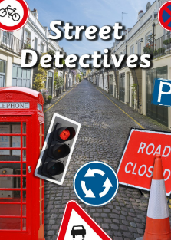
Please complete THREE over the half-term and send them in as soon as they are complete. While restrictions are in place, the best way to submit your child’s homework is to send a photo on ClassDojo. You could also attach a photograph of a model, PowerPoint, Word document etc.
Tasks can be completed in a variety of ways - be as creative as you want!

