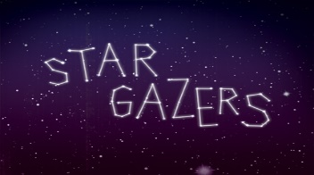
Y5 Project homework Autumn 2

Use non-fiction books, astronomy magazines and the web to find and record your own amazing facts about space. Create a space scrapbook using your facts and downloaded images. | 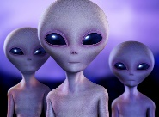  Imagine… an alien spaceship has crashed and landed in your back garden. Write your own story about what happens next. Remember to use powerful vocabulary to bring your story (and alien) to life! | Create a 3D model of the solar system which displays all the planets in order. | Write a film review of a space-themed film that you have watched with your family. Some great films to choose might be ‘Wall-E’, ‘ET’, ‘Star Wars’ or ‘Apollo 13’. How many ‘stars’ would you award your film?
So far, 24 astronauts have visited the moon. Find out their names, download pictures and record interesting facts about them. | Write a letter of application to the UK Space Agency to become an astronaut. What personal qualities or skills would you need to carry out this role? | Design and create your own astronaut space helmet or alien headwear using junk materials. | 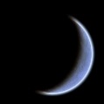  Keep a Moon diary over the course of a Lunar month. Draw the shape of the Moon each night, finding out and recording the correct term for each Lunar phase.
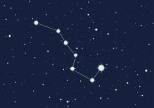  Using non-fiction books and online research, find out the names of some of the best known constellations. On a clear night, try to identify them. Draw diagrams of those you have spotted. Do you think the names they have been given suit them? | Visit your local library and search for space-themed books. This could be non-fiction, novels or poetry. Write a review of your favourite to display in school. | Help a sibling with their project  homework.

Please complete THREE over the half-term. While restrictions are in place, the best way to submit your child’s homework is to send a photo through ClassDojo. We will show them in class by the end of that week. You could attach a photograph, a PowerPoint, a Word document etc.
Tasks can be completed in a variety of ways - be as creative as you want!

