Create a quiz!  Create a ‘What am I?’ quiz by selecting parts of the digestive system and the describing them in turn with clues. | Help a sibling with their homework and take photos or write about what you did. | Use books or internet to research the digestive system. Draw and label what you find. Can you copy the organs carefully? | Could you make a model of one of the organs of the digestive system?
 | Blank for your own idea:
Create a word search or crossword puzzle containing some of the key topic vocabulary you have learned.  Ask a friend or family member to solve it! | Find out how to look after your digestive system.  Make a song or poster encouraging people to look after their guts (digestive system) and explain why it’s important. | 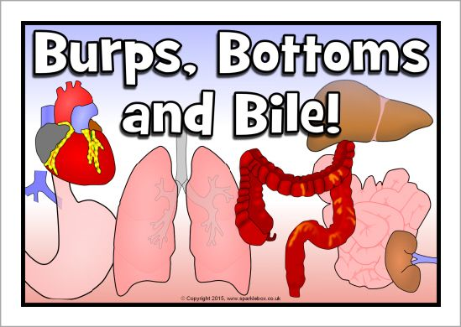 | Find a recipe for a dish that is good for your digestion. Now cook or bake it! Record your experience, maybe including some photos or drawings.
Use books or internet to research teeth. Create a poster to explain why brushing and looking after your teeth is so important! e.g. How long should they be brushed for? How often? | 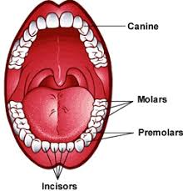 | What qualifications do you need to become a dentist? (You could look online or ask one!) | Drop grubby copper-plated coins (1p or 2p) into a range of fizzy drinks and leave them overnight to see what happens. Which brand has the most powerful cleaning properties? How might this affect your teeth?!
Y4 Autumn 2 Project homework: Burps, Bottoms and Bile

Please complete THREE over the half-term. While restrictions are in place, the best way to submit your child’s homework is to send a photo through ClassDojo. We will show them in class by the end of that week. You could attach a photograph, a PowerPoint, a Word document etc.
Tasks can be completed in a variety of ways - be as creative as you want!

