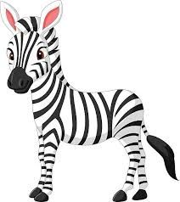
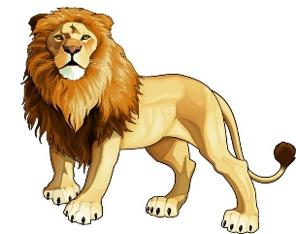
Reception Project Homework Why do zebras have stripes? Spring 2

Our topic this half-term is called ‘Why do zebras have stripes’ The children will be learning all about jungle and African animals and the habitats they live in. We will be comparing these animals to ones we already know.

Please complete the homework choices below during Spring 2 and send them as in soon as they are complete. While restrictions are in place, the best way to submit your child’s homework is to send a photo through ClassDojo. You could send a photograph of a model or picture, or a video through ClassDojo.
Tasks can be completed in a variety of ways - be as creative as you want!
Pick your favourite jungle animal. What information can you find out about this animal? Can you make a mask of this animal? Be as creative as you can! | Some animals live in a zoo. Have you ever been to a zoo? Research what zoos look like. What do they do to look after the animals and make sure they are happy? | Many animals have different patterns on their fur. Some of them have stripes or spots. Can you draw or make a jungle animal but give them a different pattern? Would they make a different noise? How would they move?

