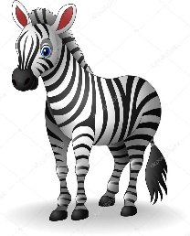
Nursery Spring 2 Project homework – Why do zebras have stripes?
Our topic this half term is called ‘Why do zebras have stripes?’ We will be learning all about wild animals, African culture, animal patterns and camouflage.
Please complete some of the homework choices below during Spring 2 and send them in as soon as they are complete. While restrictions are in place, the best way to submit your child’s homework is to send a photo through ClassDojo.
Tasks can be completed in a variety of ways - be as creative as you like!

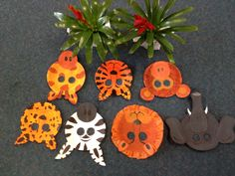  Can you create an animal mask of your favourite jungle/safari animal using a paper plate and recyclable materials from around your house? | It is important to practise writing your name regularly. Remember to use the rhymes for each of the letters in your name to form each letter correctly. | Ask an adult to draw a long snake on a piece of paper. Can you use 2 different colours to create a repeated pattern to colour in your snake?
The jungle can be very noisy place with all those wild animals! Can you make some of the noises the animals make? Can you roar like a lion, squawk like a parrot or hiss like a snake? | 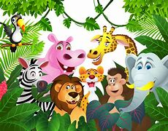 | Wild animals move in different ways. Can you move around in different ways like the animals, and see if an adult or sibling can guess which animal you are pretending to be?
The bodies of wild animals are patterned to help them hide from predators.  Can you create your own animal print or pattern? This could include spots, stripes, shaped patches, bright or even dark colours. | Share a story with an adult about a wild animal, such as ‘Dear Zoo’, ‘Elmer’ or ‘Monkey Puzzle’. Can you find out a fact about the animal from your story? | Create a pair of binoculars using recyclable materials such as kitchen roll tubes and string, ready to go on a safari adventure!  