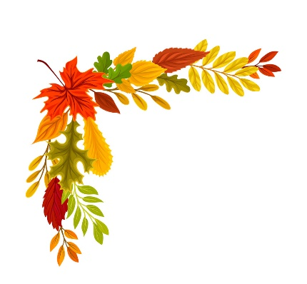
Autumn 2 Project homework – Why do leaves go crispy?

Our topic this half term is called ‘Why do leaves go crispy’. We will be learning all about the changes that occur during the season, woodland animals and their habitats and hibernation.

Please complete some of the homework choices below during Autumn 2 and send them in as soon as they are complete. While restrictions are in place, the best way to submit your child’s homework is to send a photo through ClassDojo. We will put the photographs on display and show them during our Show and Tell time. You could send a photograph of a model or picture through ClassDojo.
Tasks can be completed in a variety of ways - be as creative as you want!
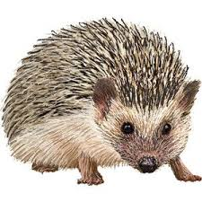
With help from an adult, find out about hibernation. What does it mean? Can you make a list of animals which go into hibernation during the autumn and winter months? | It has recently been bonfire night. Draw or paint a picture of fireworks exploding in the sky. Think about the bright colours you would see and use them to make your picture bold and bright. | Keep a weather chart for a week. Draw a picture to show what the weather is like each day. How does the weather change?
With an adult, collect some autumn leaves. Can you make a collage or picture using these leaves? | 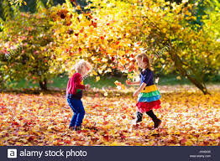 | Go on an autumn hunt and collect conkers, acorns, leaves etc. Take a photo of your autumn treasures.
With an adult, go on a weather walk. Can you spot any seasonal changes? Take photos or draw a picture to show signs of autumn. | Practise counting to 10 or 15. Use items found around your home to help. Remember to touch or point to each item as you count. | The weather is becoming much colder. Practise putting on your own coat. You may even try to zip it up yourself!

