Year Group Artist coverage

This document provides an overview of the sculptors/architects/designers that are to be studied by each group.
Sculptor | Architect | Designer

Nursery/Reception | Autumn 2:  Why do leaves go crispy? | Spring 1:  Which was the biggest dinosaur?
 | Andy Goldsworthy  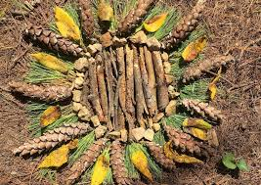 | Christo and Jeanne Claude (Wrapping architecture)  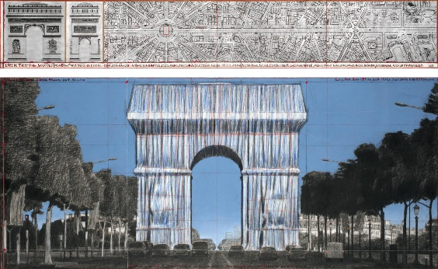

Year 1 and 2 | Spring 2  Street Detectives | Summer 2  Rio de Vida
 | Sir William Arrol (Transporter Bridge)  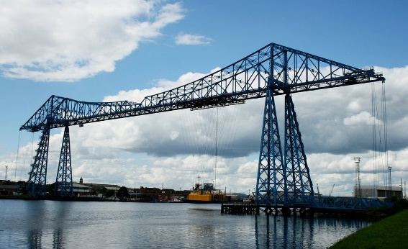 | Paul Landowski (Christ the Redeemer)  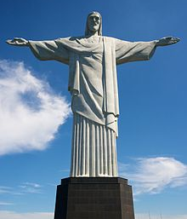

Year 3 | Spring 2:  I Am Warrior | Summer 1  Mighty Metals
 | Roman Shields  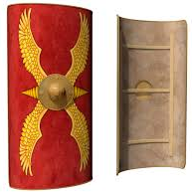 | Antony Gormley (Angel of the North)  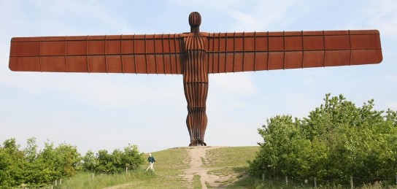

Year 4 | Spring 1:  Tribal Tales | Summer 1:  Blue Abyss
 | Bronze Age Sculptors  (Stonehenge)  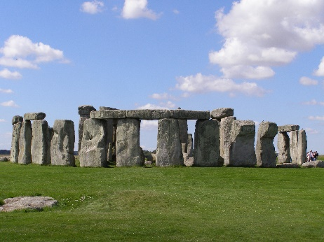 | Cornelis Drebbel  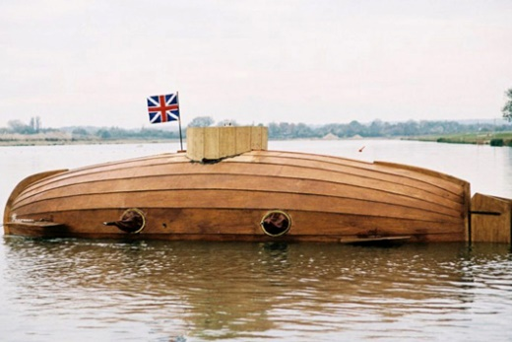

Year 5 | Spring 1:  Pharaohs | Spring 2:  Off With Her Head
 | Egyptian Nemes  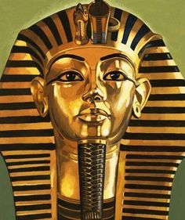 | Tudor Houses (Ryedale Folk Museum)  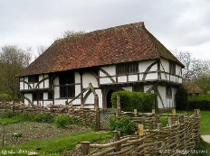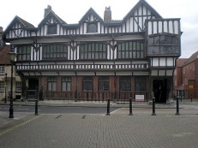

Year 6 | Autumn 1:  ID & The Heart | Summer 1:  Gallery Rebels
 | Thomas Burberry  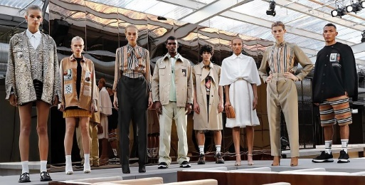  Vivienne Westwood  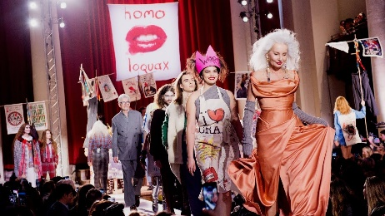 | Alfie Bradley (The British Ironworks Centre)  